**Annex I: Using and Providing the Pratt Pouch**

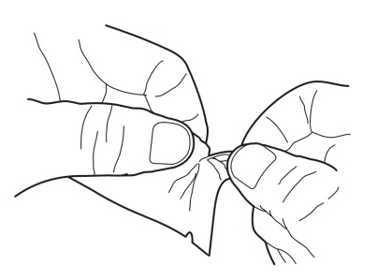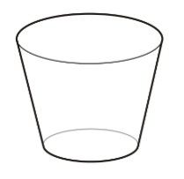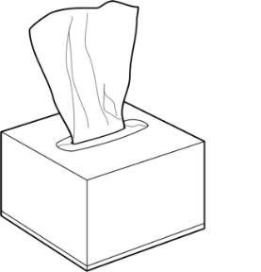**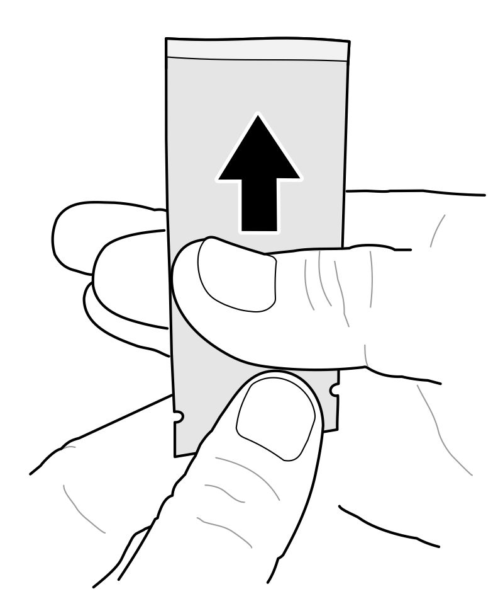[](https://portal.intrahealth.org/Departments/Communications/Image%20Library/IntraHealth%20logo/IntraHealth%20Logo%20for%20Documents%20in%20Word%20and%20PPT.jpg)**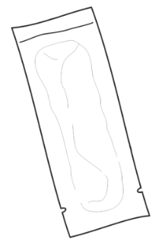

Fig. 2

**Tissue Box**

**Cup**

Fig. 1

**3.3 Holding** pouch steady with one hand, use the other hand to carefully tear through the notches to create an opening (Figure 2).

**3.2 Firmly grasp** pouch with one hand on one side of notch and the other hand on other side of notch.

**3.1 Squeeze** medicine into bottom of pouch, away from the notches (Figure 1).

**2.2 Place** baby on his or her back.

**2.1 Wash and dry hands** well before starting process.

**Part 3**: Opening the Pouch

**Part 2**: Positioning the Baby

**Pratt Pouch**

Tearing notches

Opening

**Part 1**: Assemble all Supplies

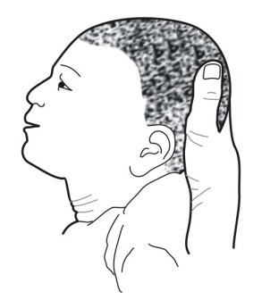

**3.4** With one hand, **prop up** the baby’s head to that he/she will be able to swallow (**Figure 3**).  
Note: In the workshop, we are using cups in the place of babies.

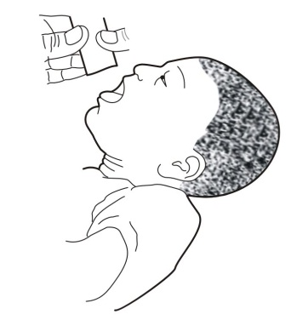

Fig. 4

Fig. 3

**3.9 If baby vomits** the medicine within one hour, provide second dose by repeating the process.

**3.8 Place used pouch** in “used” bag for return to IntraHealth. Unused pouches are returned to pharmacy.

**3.7 Empty pouch as much as possible** to ensure baby receivessufficient amount of medicine.

**3.6 Slide fingers** from bottom of pouch toward opening, slowly squeezing medicine into baby’s mouth, allowing baby to swallow as needed.

**3.5** With the other one hand, **hold pouch** just above the baby’s mouth (**Figure 4**).